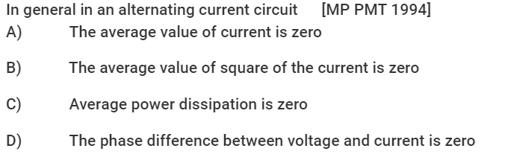

ANSWER:
- Trivial.
- Not correct because the square of the current will not average out to be zero (an always positive quantity)
- Electric appliances that run on AC, do consume power.
- It depends on the circuit. (This is dealt in subsequent lectures)

